**Experiment No.: 1**

**Aim**

**Create a student table with columns Roll.no, Name, age, marks using pandas and do**

**the following**

**a. select top 2 rows**

**b. filter a data based on some condition with mark&gt;80**

**c. filter in names first name start with  &#39;N&#39; then remaining**

**CO1**

**Procedure**

import pandas as pd

s1 = pd.DataFrame({

        'RollNo': ['S1', 'S2', 'S3', 'S4', 'S5'],

         'name': ['Nirmal Fenton', 'Ryder Storey', 'Bryce Jensen', 'Nil Bernal', 'Kwame Morin'],

         'age':[23,56,12,13,14],

        'marks': [20, 210, 190, 222, 30]})

print(s1.head(2))

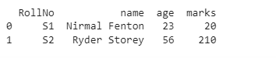

s1[s1['marks']>80]

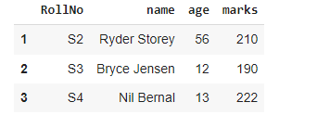

**esult**

The program was executed and the result was successfully obtained. Thus CO1 was obtained.